**Import table into eclipse**

(Note: You can create the tables in lnd3 and import data from lnd3 server to ls4)

Here we can assume that lnd3 is like a non-hana system)

1) create table in se11

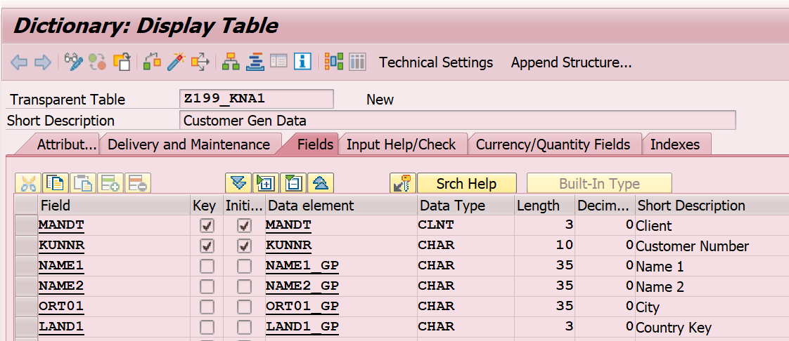

Fill it with below entries through TMG.

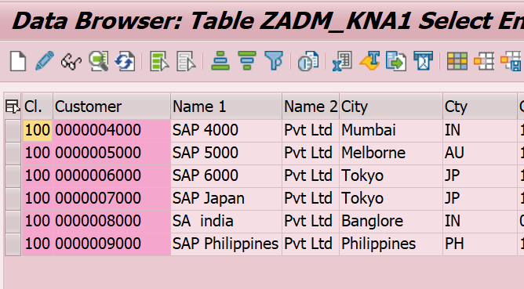

Content

1. 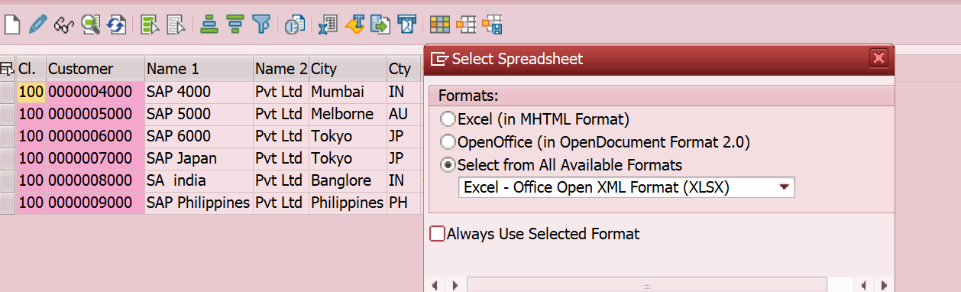





1. To import from eclipse

Modeler perspective.

Eclipse -> file -> import -> sap Hana content -> data from local file -> TRAINEE04 -> browse -> path -> header row exists check -> schematrainee04 -> tablename MT_KNA1 -> keys -> remove client MANDT field-datatyps changes- save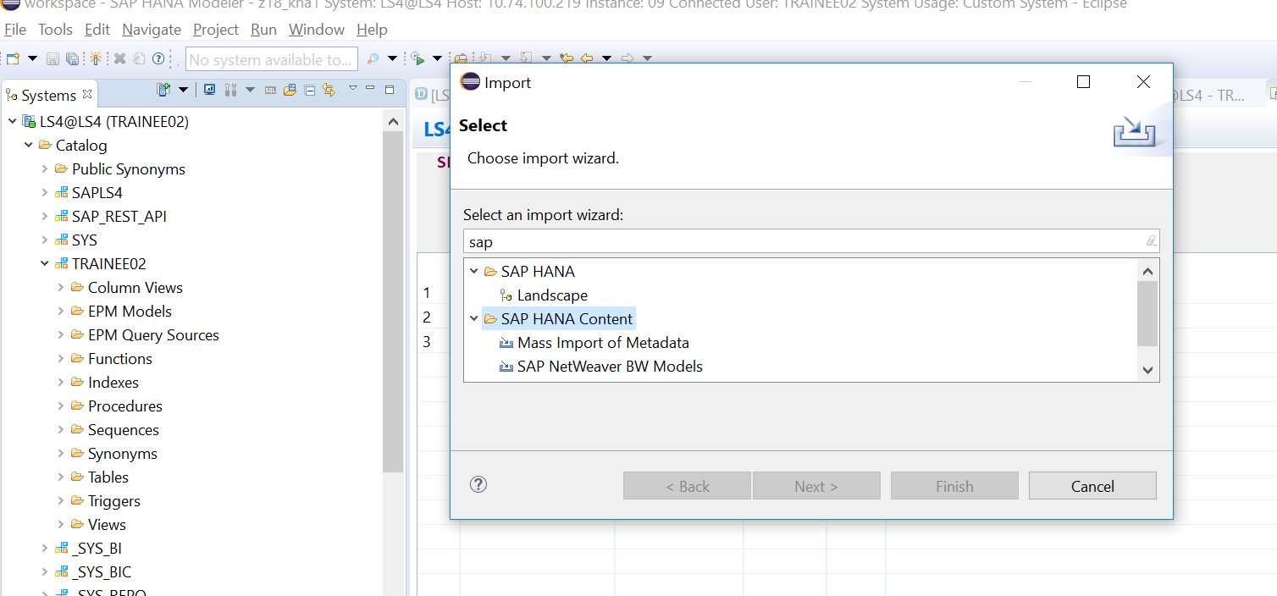

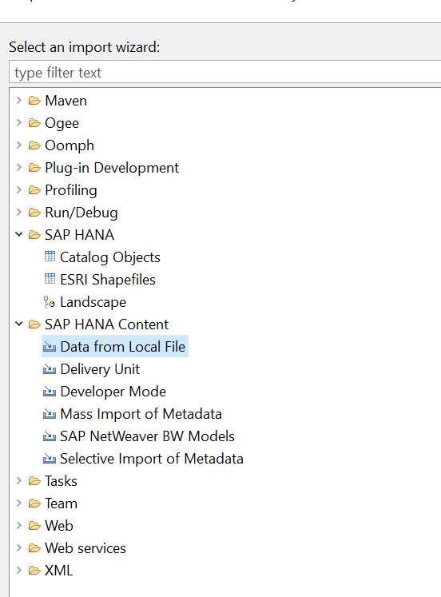

Map the fields. Remove client field.

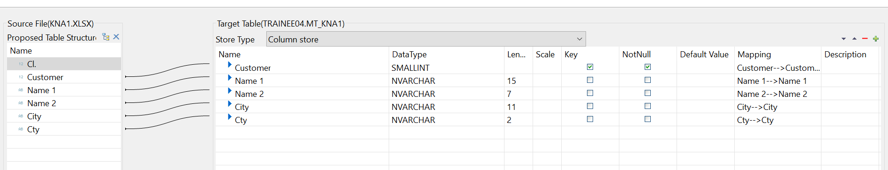

1. Check table in created
2. 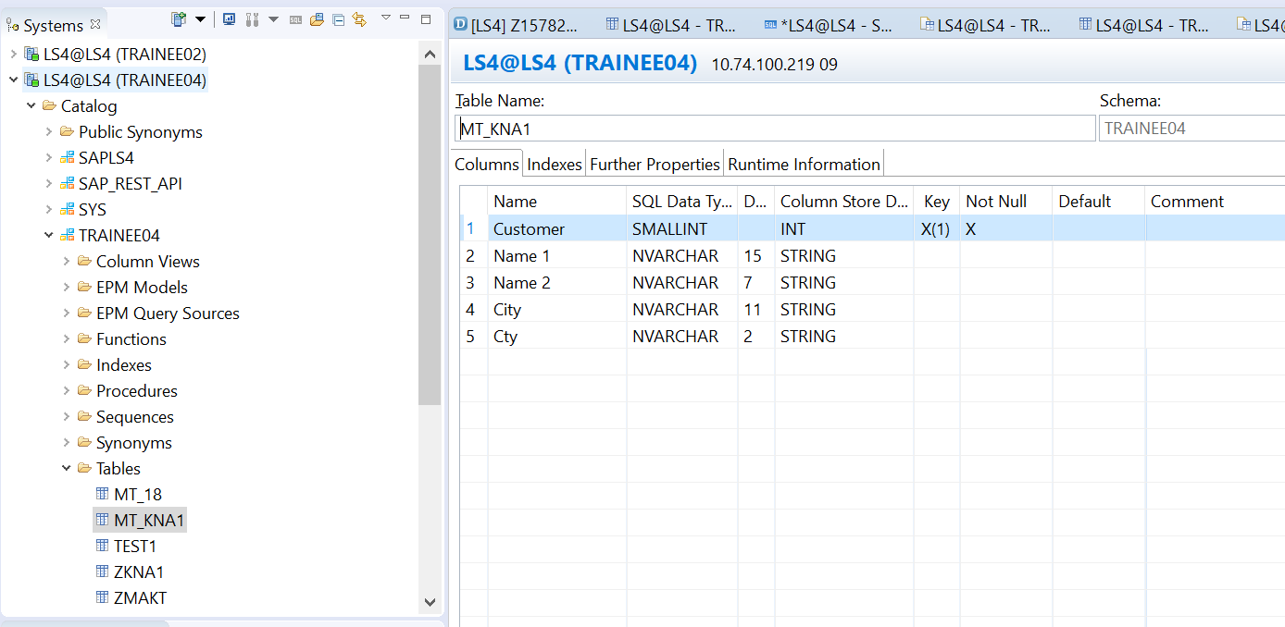
3. Write a select * query and fetch data from the table created.

**select** * **from** TRAINEE03.MT_KNA1